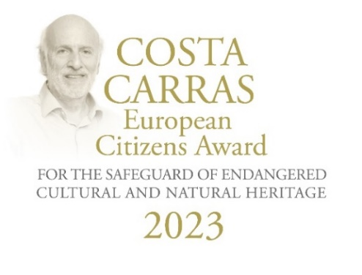



Costa Carras European Citizens Awards
for the Safeguard of Endangered Cultural and Natural Heritage

CALL FOR ENTRIES 2025

EUROPA NOSTRA and ELLINIKI ETAIRIA - Society for the Environment and Cultural Heritage are proud to launch the Call for Entries for the third edition of the Costa Carras European Citizens Awards for the Safeguard of Endangered Cultural and Natural Heritage. Costa Carras (1938-2022) was a visionary conservationist, an eminent historian and scholar as well as a distinguished businessman, a humanist, an idealist – a true Greek and a true European. For over 50 years, Costa Carras worked tirelessly in favour of Greece’s and Europe’s heritage to create a more sustainable, inclusive and beautiful world.

The Costa Carras European Citizens Awards celebrate the legacy of this iconic champion of Europe’s shared heritage, and encourage citizens to engage in defence of the values he stood for. The Awards are presented annually to a European citizen, a group of individuals or a civil society organisation based in Europe for a successful and exemplary campaign to mobilise the public to save endangered heritage in their country or elsewhere in Europe. The winner of the Golden Award receives a monetary prize of €10,000 and a certificate. The winner of the Silver Award receives a monetary prize of €5,000 and a certificate.

The applications will be examined by a Jury composed of independent experts in the fields of culture, heritage and communication from various European countries.

The presentation Ceremony of the Costa Carras European Citizens Awards will take place in the framework of the Delphi Economic Forum 2025 (9-12 April 2025), in the ancient city of Delphi, Greece.

The Costa Carras European Citizens Awards were launched in 2023 by EUROPA NOSTRA and ELLINIKI ETAIRIA. The founding partners of the Awards are the A.G. Leventis Foundation, the Delphi Economic Forum and the European Investment Bank Institute.

APPLICATION FORM 2025

Deadline for nomination: 14 February 2025 (deadline extended)
This form should be completed in English and sent in digital form by e-mail to info@europanostra.org and sepi@ellinikietairia.gr

Name and contact details of the nominator

Name (title - first name - last name):
Function:
Organisation (if any):
Address (street name and number – postal code – town – country)
Telephone:
Mobile phone:
E-mail:

Name and contact details of the nominee (a European citizen, a group of individuals or a civil society organisation based in Europe)

Name:
Organisation (if any):
Address (street name and number – postal code – town – country):
Telephone:
Mobile phone:
E-mail:
Website (if any):
Social media (if any):

Brief description of the nominee (a European citizen, a group of individuals or a civil society organisation based in Europe) and of the successful campaign developed to mobilise the public with the view of saving endangered heritage in Europe (max. 200 words)

Detailed description of the nominee (a European citizen, a group of individuals or a civil society organisation based in Europe) and of the successful campaign developed to mobilise the public with the view of saving endangered heritage in Europe (max. 1000 words)

In the detailed description of the nominee, you should include their mission and accomplishments and how this exceeds normal expectations in the given context. Also make mention of the qualities which make the nominee’s activities outstanding in a European context.

Relevant additional material

- Websites, videos and/or media articles
Please list below links to websites, videos and/or media articles related to the nominee / the campaign

- Photographs and Videos
Please provide a selection of 10 photos, in horizontal format and in high resolution (up to 2 megabytes each) related to the nominee / the campaign. Videos can also be sent.
Both photos and videos should be sent via Wetransfer.

- Reference letters
If you wish, please enclose up to three reference letters in support of the nomination. The reference letters should be in English and provided by persons other than the nominator.

- Other relevant additional material (if any)

Declaration of the applicant
I wish to nominate the above-mentioned European citizen, group of individuals or civil society organisation to the Costa Carras European Citizens Awards for the Safeguard of Endangered Cultural and Natural Heritage. I confirm that I have obtained permission from the owners of the copyrights in order that EUROPA NOSTRA and ELLINIKI ETAIRIA can freely use the photographs and material submitted for all communication and promotional purposes related to the Awards.

Place and date:

Name and digital signature of the nominator:

Attributed to citizens, group of citizens or organisations from one of the Member States of the Council of Europe (47 countries). The Award will not be given posthumously.

